

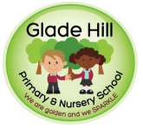
Glade Hill Primary and Nursery school
Amazing Acorns Newsletter
Spring 2 2026
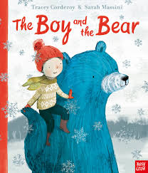
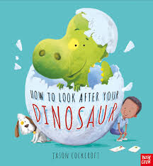
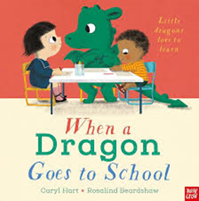
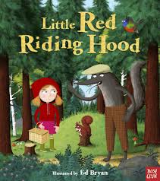
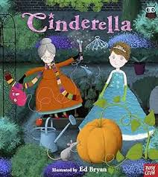
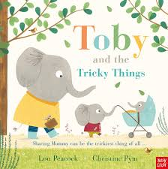
This half term the children in Nursery will be continuing our language programme called Neli Pre-school. You will continue to receive weekly ‘home learning’ suggestions which highlight the ‘special words’ that have been learned that week and, how you can further support their learning at home. Please see below for a more in-depth explanation and videos of the books that will be focussed on this half term.
In PSED, the children will remember and follow rules without adult prompts and, understand why our GOLDEN rules are important.
In Maths, the children will be focusing on subitising, counting and making groups of 4 plus, comparing amounts using ‘more/fewer/same’.
In the wider curriculum areas such as ‘Understanding the World’, the children will be learning about Ramadan, Eid and Easter. They will be exploring different sounds and going outside to observe nature.


For any questions or concerns please talk to us at the door or email us at: acorns@gladehill.nottingham.sch.uk
Mrs Beet, Mrs Pride and Miss Jardine
Reading in Nursery
- Please bring your child’s reading diary and book bag every day.
- Books must be returned on Fridays.
- Please sign and add your comments in the diary at least 3 times a week
At Glade Hill we use Every Read Counts. This will mean those that read more will reach the rewards sooner. Remember to read in the holidays too! We also have an ultimate reward for those children who go over and above and read regularly at home – this is 200 reads over the whole year!

