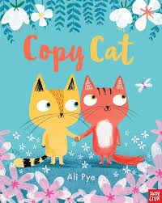

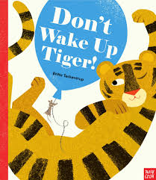
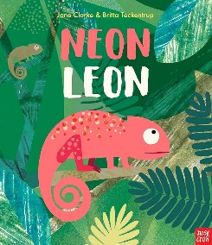

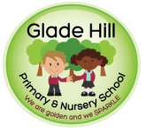
6
Glade Hill Primary and Nursery school
Amazing Acorns Newsletter
Spring 1 2026
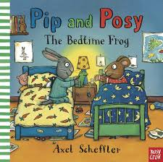
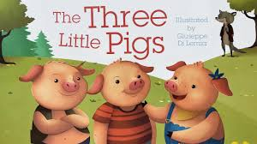

This half term the children in Nursery will be starting a new and exciting language programme called Neli Pre-school. You will receive weekly ‘home learning’ suggestions which highlight the ‘special words’ that have been learned that week and, how you can further support their learning at home. Please see below for a more in-depth explanation and videos of the books that will be focussed on this half term.
In PSED, the children will talk about their feelings and be supported in how to manage those emotions.
In Maths, the children will be focusing on subitising, counting and making groups of 3 plus, comparing size using the words ‘taller/shorter’.
In the wider curriculum areas such as ‘Understanding the World’, the children will be learning about Lunar New Year, exploring and joining materials and, combining and heating/cooling materials through cooking.

Reading in Nursery
We will soon be sending a story for you to share at home. They will also have a reading diary where we would like you to write your comments.

- Please bring your child’s reading diary and book bag every day.
- Books must be returned on Fridays.
At Glade Hill we use Every Read Counts. This will mean those that read more will reach the rewards sooner. Remember to read in the holidays too! We have also introduced an ultimate reward for those children who go over and above reading regularly at home – this is 200 reads over the whole year!



For any questions or concerns please talk to us at the door or email us at:
acorns@gladehill.nottingham.sch.uk
Mrs Beet, Mrs Pride and Miss Jardine

