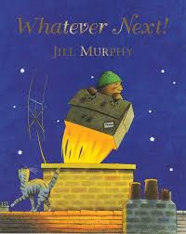
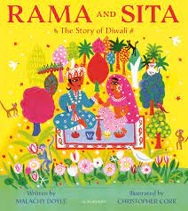
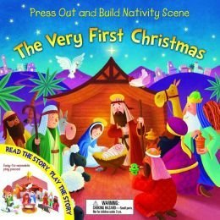
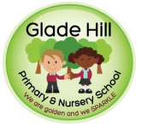
Glade Hill Primary and Nursery school
Amazing Acorns Newsletter
Autumn 2 2025
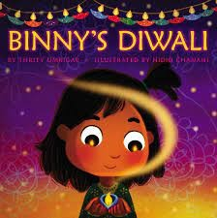

Theme: Celebration
This half term in the F1 we will be learning all about different celebrations such as Bonfire night, Diwali and Christmas. In PSHE, the children will be discussing their likes/dislikes and personal preferences during circle time. In English, we will be retelling stories and looking at new vocabulary such as diva lamps, shadows, light, stable and angels. In Math’s, we are focusing on number songs to 5 and exploring patterns within the environment. In Science, we are exploring light and dark through day/night and shadows. In PSED, we will be concentrating on teaching the children how to manage their own basic hygiene and personal needs, including dressing, going to the toilet and understanding the importance of healthy food choices. We would really appreciate it if you could also help with this at home. We will also be having lots of festive fun towards the Christmas break!

Please keep an eye on our school website, Marvellous Me and Jumiper for important updates around Christmas events such as Christmas dinner, jumper day and performances.

Outdoor Classroom. Outdoor Learning has always been a huge part of the Early Years curriculum and we are learning outdoors as much as possible at the moment. As well as our outdoor classroom we will be taking walks into our Forest school in the woods. Please ensure your child has a coat with them every day and hats/ gloves as the weather starts to get colder Please make sure all clothes, lunchboxes, bags and water bottles are labelled with your child’s name. It makes it so much easier to return them when they are lost!


For any questions or concerns please talk to us at the door or email us at: acorns@gladehill.nottingham.sch.uk
Mrs Beet, Mrs Pride and Miss Jardine

