Year 1- White Rose Yearly Overview
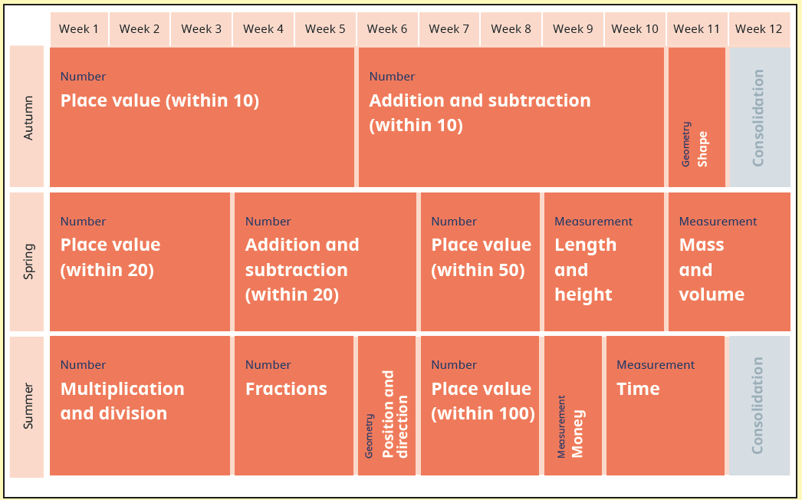

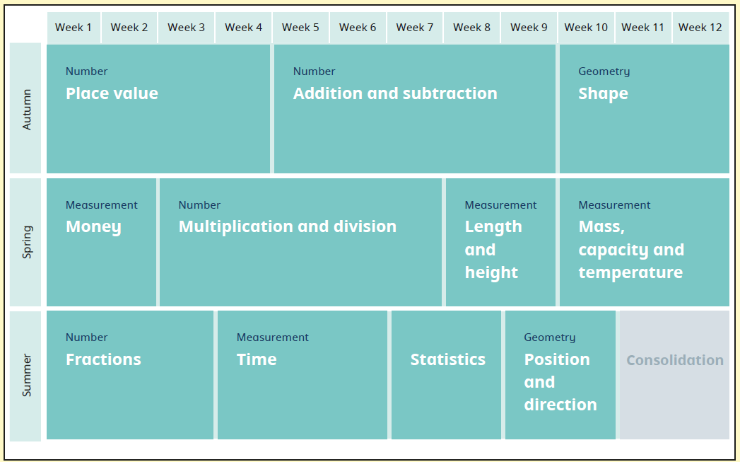
Year 2- White Rose Yearly Overview

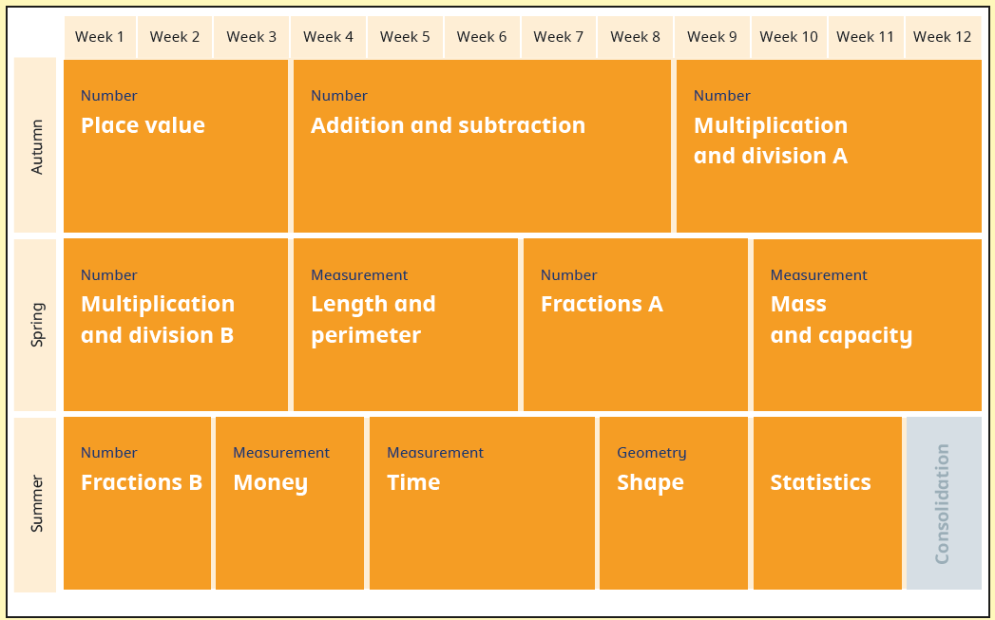
Year 3- White Rose Yearly Overview

Year 4- White Rose Yearly Overview
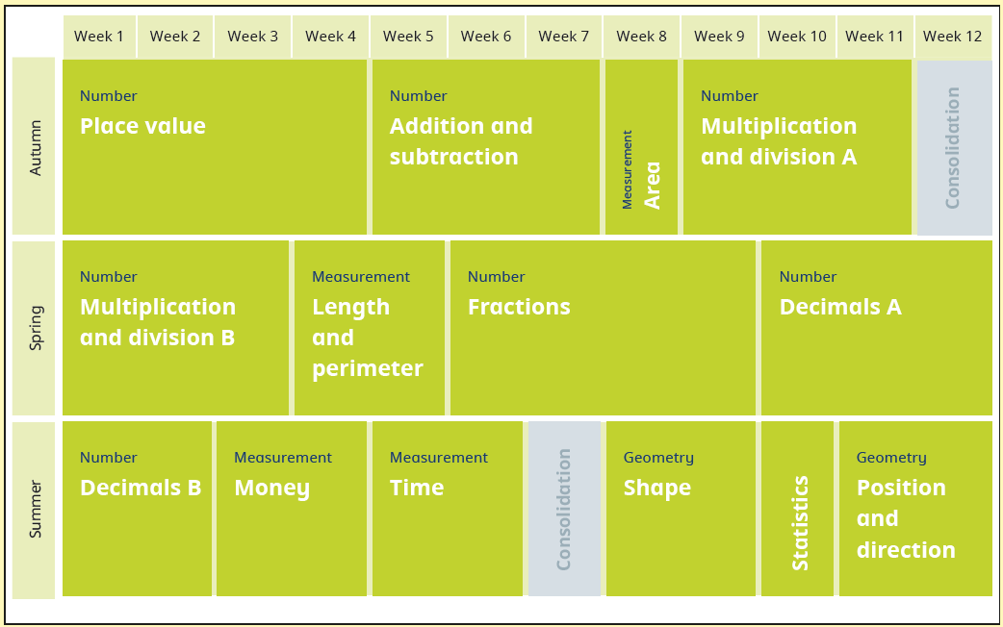
Year 5- White Rose Yearly Overview
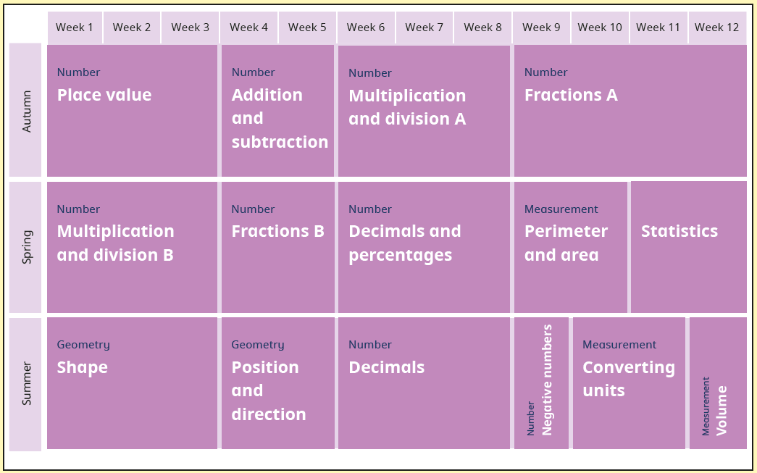
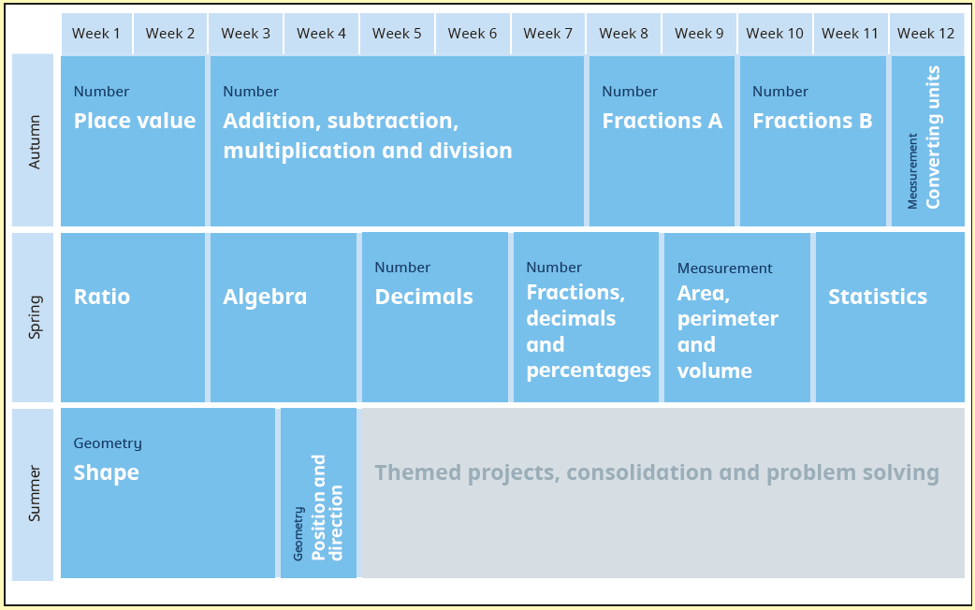
Year 6- White Rose Yearly Overview

