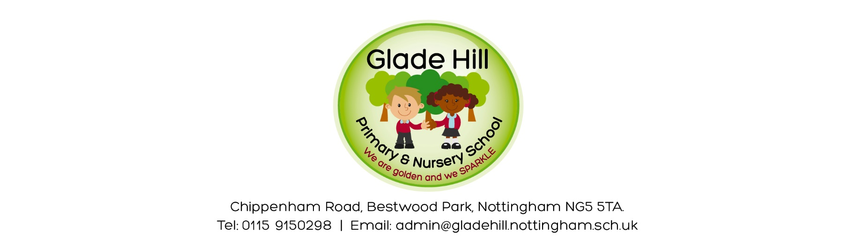

Glade Hill Book Swap

Dear Parents / Carers

This half term’s focus is ‘Love For Books’ and as part of that, I would like every child to take part in a book swap. This will involve every child bringing in a book they don’t want anymore, and they’ll get to take home (and keep) another one.

Please can your child bring in a book they don’t want anymore into school by Thursday 21st March but ideally before this. Children will just need to give their books to their class teachers, and I will then collate them all.

The Glade Hill Book Swap will be on Thursday 21st March and we’d like every child to be able to take a book home.

Please feel free to bring more than one book – this will ensure everyone has the chance to get a book to take home.

There will also be a parent book swap that day (after school)! More information about this to follow.

Thank you so much in advance!

Kind regards,

Miss Whiles

