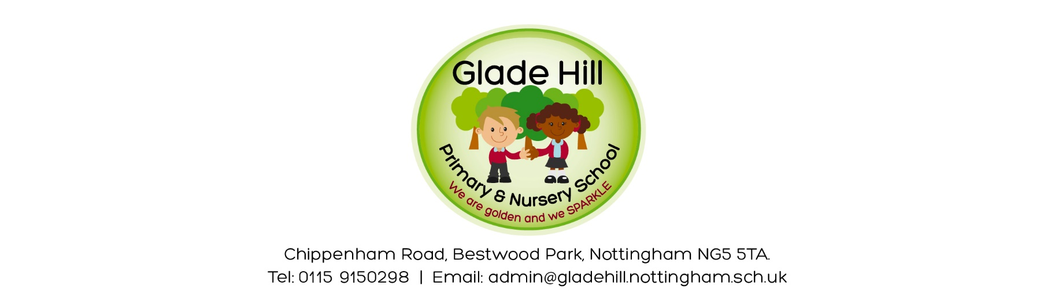

Glade Hill Book Swap

Dear Parents / Carers

As part of our ‘Love For Books’ half term, we are having a book swap on Thursday 21st March and we’d like to have a parent book swap after school at 3pm on this day. This will be in the office so that we can supervise and stop any children taking an adult book by mistake. The children’s book swap will be during the school day.

Please can bring any books you don’t want any more for the parent swap before this date. You can either give them to your class teacher or the office.

Please can you ensure the books are appropriate to be swapped in school, and are in a good condition.

Please feel free to bring more than one book. The book swap is open to all parents – even if you haven’t brought a book in! I’m hoping there will be plenty to go around!

Thank you so much in advance!

Kind regards,

Miss Whiles

