

World Book Day 2024 – Thursday 7th March

Dear Parents / Carers

World Book Day is on Thursday 7th March 2024 and we have lots of exciting things planned.

Firstly, on Thursday 7th March, we’d like your child to come in either their comfy clothes, or they can dress up as their favourite character from a book. It is completely up to you!
The FROGS have organised a Costume Swap Shop for Thursday 29th February under the canopy. A reminder that if anyone has any donations, please bring them in before that day would be great.

Secondly, we’re going to have a class competition for the best ‘toilet roll book character’. The prize for this will be a £5 book voucher.
See below for inspiration for toilet roll characters. These can be brought in from the week commencing Monday 4th March, with the final deadline of World Book Day (7th March).
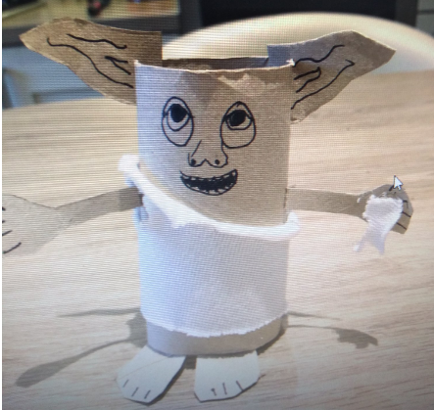
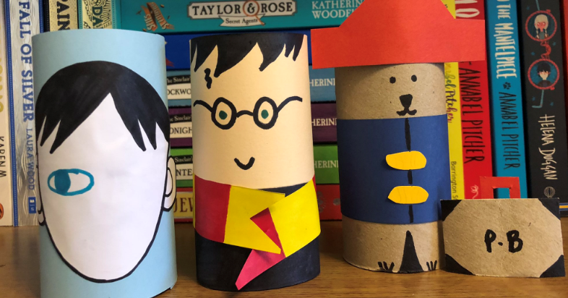
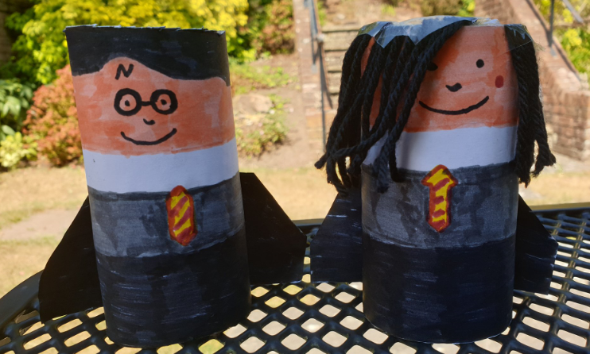

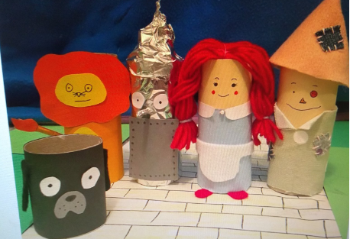

Your child will be bringing a book voucher home, which can be spent in Asda, Blackwell’s (selected stores only), Sainsburys, Tesco, The Works, Waterstones and WHSmith.
In exchange for the £1 token, children can receive a World Book Day £1 book for free, or get £1 off a full price title any full price book or audiobook (as long as the book or audiobook costs at least £2.99) in participating booksellers only, subject to stock availability.

Finally, we’d like to share some funny poems on World Book Day, so if your child would like to, please bring a funny poem in on the 7th March!

We look forward to celebrating World Book Day together. Don’t forget to hear your child read aloud at home and to sponsor them for our fundraiser that ends next Friday!

Kind regards,
Miss Whiles

