Taking an active interest in your child’s learning is one of the best ways you can help your child to do better in school and in life.

Learning is not just about what happens in school. Children are learning all the time through what they see, hear and do.

A little reading goes a long way!

- Remember: a good 10-15 minutes, 3 times a week is much better than a difficult half hour once a week!
- Plan a quality, quiet time to read together.

Strategies and Reading Behaviours

In school children are taught a range of strategies they can use to help them work out unknown words.

For example:
- Phonics! If they can ‘sound out’ the word using the phonics they know then encourage this
- Use the picture as a clue (this is not cheating!)

Uses picture clues along with the initial letter in the word

Predicts what the word could be from the context it is in and what they know about the setting and the story


As children’s reading skills develop they adopt a range of good reading behaviours.

These include:
- Reading from left to right and matching each spoken word to a written one
- Recognising errors
- Re-reading to correct and re-reading to check
- Making meaningful but not always accurate guesses

- Reading with expression

As children progress further they:
- Use punctuation
- Follow print with their eyes
- Search for information in the print
- Read more fluently
- Use letter clusters to attempt new words

Reading with your child

Book Introduction: Spend time introducing the book (see the sheet ‘Questions to help you get more from your child’s reading book’)

Strategy Check: Ask your child “What can we do if we get stuck on a word?” Listing the strategies refreshes your child’s memory and gives them the confidence to tackle a new word.

Independent reading: During this time try to remind your child of strategies rather than giving unknown words.
Returning to text for questioning: (see the sheet ‘Questions to help you get more from your child’s reading book’) This is an important part of the reading session as it enables you to see if they have understood what they have read. More confident readers will also be able to return to the text to find out answers to questions.

Important points to remember

- Allow your child to read to the end of a sentence without interrupting.
- Share the title rather than asking them to read it if the words are unfamiliar.
- Remind your child to point to each word individually rather than continuously run their finger underneath if they are still learning to match one to one.
- Rather than just saying well done or that was good, tell your child what was good e.g. well done, you used your phonics to work out that word.
- Remember not to expect your child to work out a word that is not in their vocabulary.
- Alternate the strategies you suggest rather than giving the same strategy prompt e.g. ‘sound it out’ every time.

Remember, we all learn more when we enjoy what we are learning!

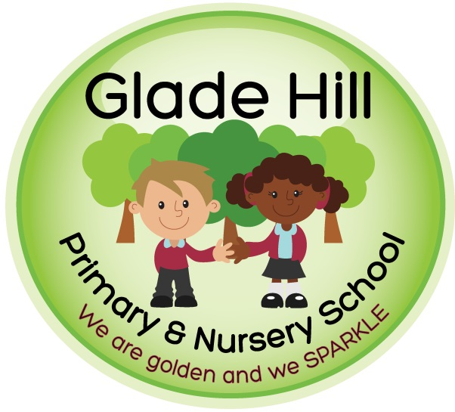

A quick guide to: Reading at home

